Lab 09

- ) Leagues
league_name -> * none *

Teams
team_name -> the set and all subsets of {league_name,age_group,cid}

Players
pid -> the set and all subsets of {fname,lname,address,phonenumber}

Coaches
cid -> the set and all subsets of {fname,lname,addres,phonenumber,years_coached}

Assistant_Coaches
team_name,cid -> * none *

Team_Players
pid -> team_name due to UNIQUE(pid) constraint
team_name,pid -> * none *

Coach_Age_Groups
cid, age_group -> * none *

2.)
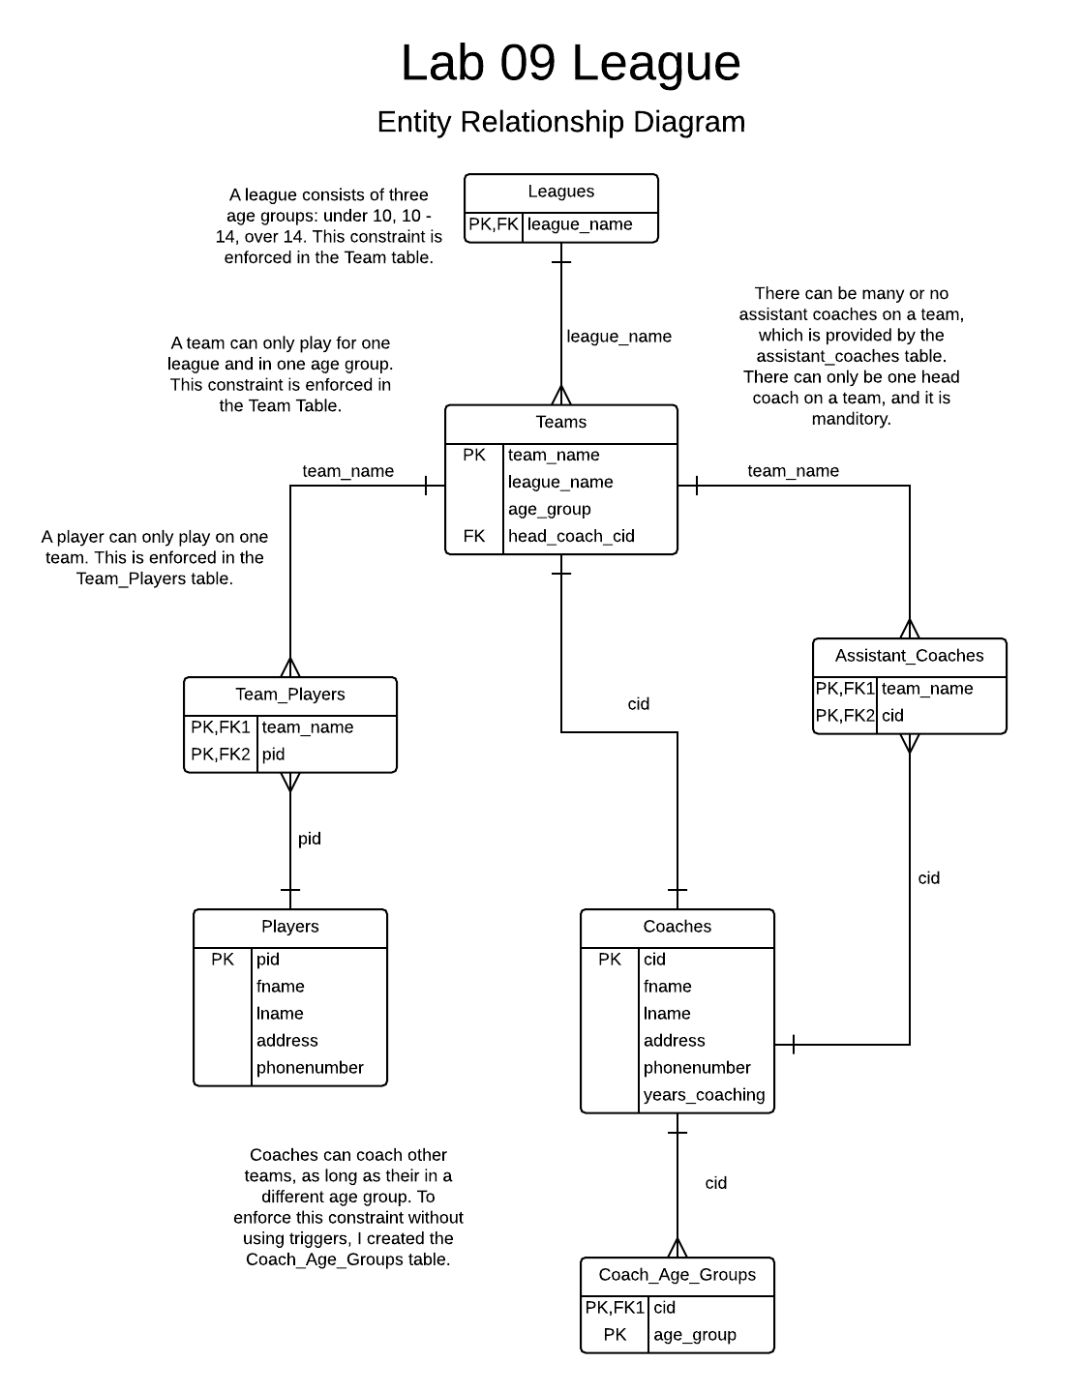

3.) To prove my database is in NF3, first I must prove its in NF1. Its in NF1 as all data is atomic. Next I prove its in NF2. Its in NF2 as its in NF1, and using the dependencies I see there are no non-primary attributes dependent on just one part of a subset of a candidate key. Finally I prove its in NF3. Its in NF3 as its in NF2, and their are no transient dependencies in the form A-> B and B-> C so A -> C where A != C. In fact, their are no transient dependencies so its in BCFR.

